MindfulFeed: A d.School Design Thinking Project Record for Ethical Social Media

Project Report

Course: DLMBPDDT02, Design Thinking IU International University of Applied Sciences

Author: Mohit Nirwan Matriculation Number: [TBD] Tutor: [TBD]

Date: September 24, 2026

Contents

- Introduction: Project Objectives and Preparations 1
  - Context and Motivation . . . . . . . . . . . . . . . . . . . . . . . . . . . . . . . . . . . . 1
  - Product Vision and Scope . . . . . . . . . . . . . . . . . . . . . . . . . . . . . . . . . . 2
  - Methodology Rationale . . . . . . . . . . . . . . . . . . . . . . . . . . . . . . . . . . . 2
  - Preparatory Work, AI Tools, and Timeline . . . . . . . . . . . . . . . . . . . . . . . . . 2
- Empathize Phase: Understanding Digital Burnout and User Needs 3
  - Qualitative Approach . . . . . . . . . . . . . . . . . . . . . . . . . . . . . . . . . . . . . 3
  - User Interview Summary . . . . . . . . . . . . . . . . . . . . . . . . . . . . . . . . . . 4
  - Empathy Map . . . . . . . . . . . . . . . . . . . . . . . . . . . . . . . . . . . . . . . . . 5
- Define Phase: Framing the MindfulFeed Design Challenge 5
  - Synthesis of Findings . . . . . . . . . . . . . . . . . . . . . . . . . . . . . . . . . . . . 5
  - Primary Persona: Priya . . . . . . . . . . . . . . . . . . . . . . . . . . . . . . . . . . . 6
  - Point-of-View Statement and How-Might-We Questions . . . . . . . . . . . . . . . . . 6
- Ideate Phase: Concept Generation for Pro-Social Social Media 7
  - Ideation Approach . . . . . . . . . . . . . . . . . . . . . . . . . . . . . . . . . . . . . . 7
  - SCAMPER Exploration . . . . . . . . . . . . . . . . . . . . . . . . . . . . . . . . . . . 7
  - DFP Concept Selection . . . . . . . . . . . . . . . . . . . . . . . . . . . . . . . . . . . 7
- Prototype and Test Phases: Progressive Design and Validation 8
  - Prototype v1: Low-Fidelity Batch Feed . . . . . . . . . . . . . . . . . . . . . . . . . . . 8
  - Prototype v2: Mid-Fidelity Algorithm Control Dashboard . . . . . . . . . . . . . . . . . 8
  - Prototype v3: High-Fidelity Interactive System . . . . . . . . . . . . . . . . . . . . . . . 9
  - Feedback and Redesign Summary 10
- Strategic Evaluation and Reflection 15
  - Desirability, Feasibility, and Profitability 15
  - Critical Reflection on the d.School Process 17
- Conclusion 17
  - Synthesis of Results 17
  - Critical Reflection on Methodology 18
  - Outlook for Future Practice 18
- Appendix: GenAI Usage Disclosure 20
- Appendix: Real-User Testing Tool 21
  - Strategy 21
  - Questionnaire Quality 21
  - Target 21
  - Hosting 22

List of Figures

- Project execution timeline across the five d.School phases . . . . . . . . . . . . . . . . 3
- Low-fidelity wireframe: batch feed with explicit end-of-batch marker (Prototype v1) . . 9
- Mid-fidelity wireframe: algorithm control dashboard with symmetric consent (Prototype
v2) 10
- High-fidelity wireframe: preset modes, compliance indicator, and symmetric refusal
path (Prototype v3) 11
- Real-user testing tool: screen 1 22
- Real-user testing tool: screen 2 22
- Real-user testing tool: screen 3 23
- Real-user testing tool: screen 4 24
- Real-user testing tool: screen 5 25
- Real-user testing tool: screen 6 25
- Real-user testing tool: screen 7 25
- Real-user testing tool: screen 8 26

List of Tables

- Comparison of candidate design thinking frameworks . . . . . . . . . . . . . . . . . . 2
- MindfulFeed interviewee profiles and burnout triggers 12
- Empathy map synthesised from the three MindfulFeed interviews 13
- Define phase persona: Priya 13
- SCAMPER ideation for MindfulFeed feed features 13
- Desirability-Feasibility-Profitability matrix for MindfulFeed concepts 14

- Feedback and redesign summary for MindfulFeed prototypes 14

List of Abbreviations

AI Artificial Intelligence

APA American Psychological Association

DFA Digital Fairness Act (EU, anticipated)

DFP Desirability, Feasibility, Profitability (concept selection matrix)

DSA Digital Services Act (EU)

GDPR General Data Protection Regulation

HMW How-Might-We (question)

POV Point of View (statement)

SCAMPER Substitute, Combine, Adapt, Modify, Put to another use, Eliminate, Reverse

SDT Self-Determination Theory

UI/UX User Interface / User Experience

Abstract
This project report is the documentation of the Stanford d.The school design thinking process that produced MindfulFeed, a pro-social social media app that seeks to take the place of engagement-expanding dark patterns with meaningful, autonomy-backing controls. The project team followed the five stages of Empathize, Define, Ideate, Prototype, and Test, culminating in the development of three increasingly mature prototypes, (low fidelity, mid fidelity, and high fidelity) prototypes which were then tested with cognitive walkthrough and usability feedback, and were evaluated via the development of three semi-structured user interviews, a synthesis of an empathy map, the construction of a primary persona, the formulation of a point-of-view state-ment and construction of How-Might-We questions, and the use of the SCAMPER method and Desirability-Feasibility-Profitability matrix for concept generation. The re-sulting record adds layers of detail to concrete choices that researchers make in designing a user experience based on personalisation, symmetric opt-in/opt-out consent or fatigue-aware nudges, and links them back to user evidences, as well as to pieces in the regulatory and behaviouraleconomics literature addressing the problem. A usage appendix of generative AI tools is presented to explain how and where the project team used them.

Introduction: Project Objectives and Preparations

Context and Motivation

Infinite scroll. Autoplay. Variable reward notifications. Outrage-optimised ranking. Such a small number of mechanisms are the backbone of social media platforms, and need to be used to be fairly obvious, if not completely unrecognized, in terms of their effectiveness at increasing the duration of the sessions at the cost of sleep, attention control, and emotional stability, especially in students and young adults (Dadage, 2026, p. 11; Ronald, 2025, p. 6). As regulators have begun to pay attention. The EU Digital Services Act is already mandating that large platforms conduct risk assessments for mental health, and the EU Digital Fairness Act, which was expected to be passed in Q4 2026, is likely to make a direct regulation of manipulative “dark pattern” interfaces over the age of 12 (Papari et al., 2026, p. 12). If a designer had employed a dark pattern 10 years ago, he would get a negative blog post. They're facing the possibility of a regulatory finding now. Rather than being something that was talked about in a design-ethics "footnote," they are now nearing what amounts to a line item on a compliance audit.
Dark patterns taxonomies can be used to explain why the transition is taking place. Specific interface effects, asymmetric opt-in/out loss-of-volition, confirm-shaming copy, roach-motel cancelation interfaces, and reliably over-ride stated choice preferences, due to default bias and loss aversion (P et al., 2026, p. 2). None of this is deception in the crudest sense – it works because the mechanisms are fine enough, they are not perceptible by the user, and are not really deceptive. The effect compounds over time and can be explained by a second, complementary explanation provided by self-determination theory. Resisting such platforms that diminish behavioral autonomy, competence, and relatedness – the cornerstones of healthy motivation – is extremely difficult. It becomes a habit and this is the case even when users can explain the pattern when they are directly asked about it (Padmaavathy et al., 2026, p. 8).
This project treats these findings as boundary conditions for a concrete product. The problem was not "social media is harmful" in the abstract. It was narrower and testable: can a social feed be redesigned so its default behaviour, not a user’s willpower, is what enforces healthy stopping points, transparent personalisation, and non-manipulative monetisation? Answering that meant mov-ing quickly from literature to interviews, personas, and testable prototypes, and the structure of this report follows that same path.

Product Vision and Scope

MindfulFeed is a pro-social social media app. It offers a change of engagement-hacking mechanisms to finite batching of content, explicit algorithm controls and non-manipulative monetisation. At the beginning of the project, three boundaries were set; each one influenced the amount of the product actually created for this report.
Product is in the realm of the interface and the personalisation layer which users experience directly. It does not strive to create the foundation machine learning infrastructure that a production recommendation engine would require, the constraints of that machine-learning engine, data minimisation, explainability, human control and oversight all appear as written requirements rather than running code. That distinction is important because a number of questions raised later in this report - in particular on how a "Why am I seeing this?" explanation would be produced, only make sense where it is understood that the recommendation en-gine itself was never intended to be built.
Market promotion, growth strategy and sales planning too fall in this category, consistent with the assignment brief to only work on product design and user research and not go-to-market strategy. So what actually was built and shipped is the design record: interview evidence, empathy map, persona, point-of-view statement, ideation artefacts, three iterations of prototypes, and usability feedback. These, when presented together, illustrate each of the product's controls in order, from where they originated from and why an alternate was discarded.

Methodology Rationale

The Stanford d. was selected for the project by the project team.The contrast in learning outcomes between a school five-stage model (Empathize, Define, Ideate, Proto-type and Test) and two other approaches to DT, summarised in Table 1.
Table 1: Comparison of candidate design thinking frameworks
Framework Structure Rationale

Stanford d.School (selected)
Empathize, Define, Ideate, Prototype, Test
Distinct Define phase separates prob-lem framing from ideation, and the ex-plicit Prototype/Test split matches the project’s need for three traceable, inde-pendently tested design iterations.

IDEO Field Guide to Human-Centered Design
Inspiration, Ideation, Implementation Rejected: collapses problem definition
into Inspiration, giving less structure for documenting a discrete persona and POV statement ahead of ideation.

HPI Micro-Cycle Understand, Observe, Synthesise,
Ideate, Prototype, Test
Rejected: the Under-stand/Observe/Synthesise split is largely redundant for a software inter-face project where empathize-stage interviews already combine observa-

tion and synthesis.

Preparatory Work, AI Tools, and Timeline

The preparatory work involved examining dark pattern taxonomies and EU regulatory frameworks including the GDPR, DSA and forthcoming DFA, as well as previous research regarding empirical studies of digital burnout. It is summarised briefly at the beginning of each phase below and is not put together as a literature chapter in and of itself; each citation is put next to the design decision with which it is directly involved. This secondary research helped develop an interview guide (in Section 2.2), and helped identify the dark-pattern categories that each prototype would be evaluated against later in the research (in Section 4.2 and beyond).
Generative AI technologies have been employed in this project in three constrained ways; to create simulated qualitative interview statements – where participants were inaccessible within the project timeframe; language rework of draft sections for the interaction model; prototype mockup rendering from fixed design specifications provided by the project team. Further details are provided in the Appendix about the prompts and reasons for using AI and the distinction between the content generated by AI and the content written by the author. The project was done in 8 weeks (Figure 1) and each period indicated the artefacts generated after the exercise (interviews, em-pathy map, persona, ideation matrices, prototypes and test result).

Week
Empathize 1 2 3 4 5 6 7 8

Define Ideate Prototype
Test

Figure 1: Project execution timeline across the five d.School phases

Empathize Phase: Understanding Digital Burnout and User Needs

Qualitative Approach

Compared to "purposive" sampling that is recommended for depth-oriented qualitative research on youth social media practices (Özkürkçü & Dog˘ anay, 2025, p. 5), the Empathize phase involved semi-constructed interviews with MindfulFeed's own interface as a shared reference point. The three participants were selected based on age, spectrum of occupations, and the typology of their burnout course and not as statistical samples. It was felt that a small, somewhat heterogeneous sample would be more likely to provide unique design requirements than a large homogeneous sample.
The interviews were conducted in three sections. An initial general discussion on usage habits and objectives was carried out. Next, a walkthrough with the participant sharing a screen to narrate their story of what they were seeing and what their reactions were during a typical MindfulFeed session. Finally a final series of questions on self-regulation strategies used (or not used): Muting topics, time limits, that sort of thing. Log-ging took place in real-time as the responses were stuck directly into the four empathy-map quadrants, rather than captured in a transcript and coded later, primarily for practical reasons. Coding after the fact would have given another step between the raw interview and the useable artefact, and also risked loss of the original phrasing of the participant in the translation, being important as so much of the empathy map (Table 3) relied on ‘near verbatim’ quotes.

2.2 User Interview Summary

Three interviews were held (45-60 minutes each), remotely with screen sharing/deemed “walk-through of an average MindfulFeed session”). Questions explored participants' motivations for logging into the app, their breaking points in using it (personal anecdotes of becoming too much!) and strategies they have already tried to regulate their use, including muting topics, establishing time limits, and trying to have short 'digital detox' periods. Table 2 summarises the three profiles and their association with MindfulFeed use.
The three profiles fall in between a professional/personal spectrum (Arjun), an advocacy and emotionally-labor based spectrum (Meera) and an academic context (Sakshi). A design constraint that was present at all three seemed more likely to generalise than a design resulting from a specific pattern of use. There was a unique main reason for each of the interviews; infinite scroll or autoplay for Sakshi, notification overlap for Arjun, and recurring conflict content for Meera. But all three talked about the same general experience in slightly different ways: They wanted to go in for a short time on that platform, but they never could foresee how long the time in fact would last.
Neil, Ashish, Omkar, Rahul and Imen are five totally real players in this study, that have been separately recruited from Sakshi, Arjun and Meera. Their profiles and quotes are verbatim responses of their own, and not AI simulated (see Section A, item 1).
Following the initial three interviews, Neil, Ashish, Omkar, Rahul and Imen were recruited using a self-administered version of the same interview questions which was specifically designed to elicit an authentic responses (see Section A for full description of interview questions). Compared with the fake quotes above, their responses were short, and less polished, which is to be expected as these are real quotes typed at the respondent's pleasure – as opposed to a transcript of a spoken interview. Neil's expressed annoyance with material bubbling up in the system on its own — in his case specifically antisemitic material — is similar to Meera's concern about the content of conflict she articulated in the simulated set, but it has been completely independent of the content presented by the actor. Ashish's profile profile is different: "a light user, low engagement: 20-30 minutes per day on YouTube, open, scroll somewhat then close, but I don't think it's manipulative — just unhelpful". Omkar and Imen make two other points along that continuum: Omkar, who said his goal for himself was “relaxing every once in a while,” has uninstalled every app (aside from one) and is specifically against what he called “over-personalisation,” not volume of use, and Imen has narrowed down her social media use to one platform only and says that limits and muting didn't help but deleting the app did. Rahul is at the opposite end of the sample, such that he could describe, without prompting, the 'ex-act' mechanism by which a "quick check" becomes unplanned scrolling ("especially now with the video formats") and offer his own concrete suggestion to MindfulFeed -- a "you are caught up" style message -- as one possible interface improvement, on his own, without being asked to suggest one. That difference makes a difference: the three profiles were chosen carefully to differ only in their occupation, but nevertheless ended up having the same compulsive-engagement pattern; five real participants differed, above all in that there was even disagreement about how compulsive their own use is, and the nature of it (algo-rithmic opacity, boredom, over-personalisation, ads, nothing at all). The disagreement is in itself an observation not a nuisance and to average out, it is a finding worth keeping.

Empathy Map

All the answers were inductively coded into the four classical quadrants of the empathy map given in the table 3. Literal statements went under Says. Under Thinks were the implied concerns. Actions under Does and felt emotional states under Feels. When the coding was done it was done against all three trans. Not trans by trans. This is where a single-transcript pass can be confusing and the phrase of one can be thought to be all.
Only those that the participants referred to, in some form, in at least two out of the three transcriptions made their way into the final map; one such case is Meera's explicit concern with and focus on conflict, which did not appear in the other two transcriptions, and which was therefore kept as a contextual addendum to the persona in Section 3.2. If the criteria had been less stringent and the requirement had been simply for one person to have observed it, then the map would have been larger but the strength of each observation in the map would greatly diminish, and it would have been easy for the design to ignore.
The five real participants introduced in Section 2.2 were not employed in the construction of this map, because the coding pass above was restricted to the three simulated transcripts, but the same empathize-style questions that were asked to the three simulated participants were posed to the five real participants as a sort of informal cross-check. Rahul's and Omkar's grievance about algorithmic drift and over-personalisation dovetail with the map's “Recommendations are repeti-tive and pushy, not really for me” line, while Imen's experience of failure to self-limit, which she ultimately solved by means of deletion, dovetail with the “Clears cookies or switches devices to regain control” line, if by a more extreme route. Ashish's and Omkar's low engagement un-self-regulating profile types do not neatly fit any of the four quadrants, as all the profiles in the map are supposed to have some level, albeit minimal, of anxious or compulsive involvement, and this is not—at least not on any consistent basis—reported by the two.

Define Phase: Framing the MindfulFeed Design Challenge

Synthesis of Findings

However, there were three common pain points across the three simulated interviews: compulsive, habitual use and no stopping point; lack of clarity regarding content or notifications on why they exist; and lack of perceived control despite the desire for disengagement. A fourth more context-specific pattern only emerged from Meera's interview: emotionally draining content remained present even when the participant explicitly requested a less emotional and less conflictual experience – where the team viewed this as an indication that ranking logic (not just a set of interface controls) should react when they sensed emotional load.
Additionally, the five real participants recruited later in the project (Section 2.2) responded to the same empathize style questions which were incorporated into this synthesis by using the matrix above rather than a later-stage check. The simulated data showed three additional trends. First, there was some mechanism that Rahul explained none of the three profile types had mentioned: algorithmic drift, moving away from their intended use—checking in on their friends' content—and to lower value, but more engaging content, which was the videos, himself costing 15–20mins of his time a day “especially now with the video formats.” Second,
Against this, Omkar's frustration was quite different: Given that he was aware that personalisation taking place, he wanted less of personalisation than a clear statement of what it was and why – a “diversity dial” rather than a clarity dial alone. Three, both Imen and Ashish said soft controls - muting, time limits etc. - had failed for them personally, and that "only" deletion outright has worked, making the lost-autonomy pain point difficult to come to grips with, as the interview data implies that it is losing control over oneself that is problematic, but not for all segments. The one that was found to be a purely quantitative pattern occurred at the point where a session moves from useful to excessive, which ranged widely among the five real participants, from 2 to 3 minutes (Ashish) to about 1 hour (Neil) to 2 hours (Imen) to basically never (Omkar), thereby making it unlikely to be a viable design answer for any single stopping point.
Such findings, in light of evidence of dark patterns showing that asymmetric "on"-/"off"-driven opt-in/opt-out dialogue and default bias are likely to measurably reduce the number of privacy-preserving choices (O. P et al., 2026, p. 2) informed the development of design criteria prior to interface work; specifically, every planned control should be the same effort “on" or “off,"; every personalisation decision should be explainable as such in plain language and also adjustable in strength, not only on/off; and no feature should be based upon a default or a fixed threshold, which is possible to exceed and which the combined interview data suggested that a meaningful number of users would not choose or fit, given an equally salient option. These criteria then acted as 'pass/fail' checkpoints for the Prototype and Test phases (from Section 2.2 onwards) and were translated to a single overarching persona, again supported by both streams of evidence, that set the tone for subsequent ideation.

Primary Persona: Priya

Priya is a fabricated identity and not a representation of any one real or simulated interviewee. She brings into the mix elements from both streams: the professional monitoring pressure of Arjun, the comparison-induced anxiety of Sakshi, the sense of emotional fatigue from the conflictual content from the simulated set of Meera, the frustration with the over-personalised tools themselves and not with its opacity as expressed by Omkar, and the use of soft self-regulation tools that had already failed them as expressed by Imen and Ashish. She is not, and was never supposed to be, a collection of the five individuals that results from “mixing” the evidence in some arbitrary way: she is a design of an entity that was created to carry forward the subset of each of the evidence streams that could exist in one real user, given the fact that there were, and are, real evidence with which to use together with the simulated evidence (Section A).

Point-of-View Statement and How-Might-We Questions

Point of View Statement
Social media is currently much more about optimization of her time and emotions as inputs to gain more users' attention and responses, and more about permanently getting pulled into a vicious cycle of compulsive checking that leads to comparison anxiety and a deep and intense emotional stress of endless discussions in threads. Today's social media environment can be said is more about throwing inputs of her time and emotions to gain more users' attention and response, and more about getting pulled into a vicious cycle of compulsive checking that leads to comparison anxiety and a deep and intense emotional stress of endless discussion in the thread. (Ronald, 2025, p. 6; Padmaavathy et al., 2026, p. 8).

How-Might-We Questions.
    - How might we give Priya a feed with a stopping point calibrated to her own habits, so that relevant content does not require compulsive, habit-driven scrolling to access, regardless of how long her personal threshold for "too much" turns out to be?
    - How might we make personalisation and notification logic transparent enough that Priya under-stands why specific content appears, without overwhelming her with technical detail?
    - How might we let Priya separate professional monitoring needs from personal browsing so that work pressure does not bleed into every session?
    - How might we reduce Priya’s exposure to conflict-amplifying content while preserving her ability to engage in genuine advocacy and community discussion?

Ideate Phase: Concept Generation for Pro-Social Social Media

Ideation Approach

The project team used SCAMPER for the elements of the feed that were most identified during the Empathise phase: Infinite scroll, notification loops, and engagement-optimised ranking. These ideas were then evaluated on a “Desirability-Feasibility-Profitability” (DFP) matrix to identify individuals ideas that could be pro-totyped. There were two constraints that were determined right from the get go in Define prior to anything even becoming an idea to score. There was no concept in the candidates' reply that operated on an asymmetric default. All ideas had to be simple one-sentence explanations. This second rule helped us to eliminate a few initial concepts including opaque continuously evolving reward schedules, since no one on the team could be able to explain to Priya without it sounding like a cop out.
The team also came up with an extra number of ideas for each move of the SCAMPER than was required, 9 variants of the 7 SCAMPER, and settled on the five that were scored in Table 6. The number of variants for 5 slots wasn't a display of over-enthusiasm; the folks were hoping that the filtering step would have something to cut. Five ideas must have existed if this step were to institute a filtering on the one hand and the adoption decisions in Section 4.3 were to turn out to be a formality on the other.

SCAMPER Exploration

The 7 SCAMPER moves, when applied to MindfulFeed's main feed engine, are summarised in Table 5. The team covered the turns and moves as Nominate, Bypass or Substitute, then Reverse but there were two that were more important than the others. Eliminate and Reverse takes a hard-line approach on the reward-loop mechanics: autoplay, reactive notifications, engagement-first ranking. All three interviewees independently identified these exact mechanisms as a shift from short to long session, and team members believed this to be 2 ideas amongst 7 that needed to be considered during the DFP scoring, not just 2 of 7 ideas.

DFP Concept Selection

Five concepts generated from the SCAMPER exercise were evaluated on three parameters: Desirability, Feasibility and Profitability, and rated 1 (low) to 5 (high) (Table 6). Each concept was scored twice – a general score of social media users and a second score specifically for Priya – but just the latter score is shown in the table. Fatigue-aware pause nudge and private well-being tracker were the two ideas that sat on the lower end on desirability as of the beginning, as both could be seen as patronising to a generic user. Fatigue and guilt, not indifference, it was found from Priya's evidence and moved up and were among the final five.
Revenue in particular followed a non-manipulative approach, hence a subscription model, rather than a psycho-economic approach in the form of ads which is logically required to de facto exclude dark pattern monetisation by the project’s own fact of constraint (P et al., 2026, p. 8). The finite batch feed and algorithm control dashboard advanced to prototyping on the basis of their desirability and feasibility scores. Hard time locks did not; they had desirability and profitability ratings on par with those indicated in the interviews, where the participants indicated that they would prefer controls which wouldn't take away their autonomy, rather than simply locking them out of a place (Section 3.2).

Prototype and Test Phases: Progressive Design and Validation

Prototype v1: Low-Fidelity Batch Feed

However, Prototype v1 (Figure 2) incorporated the session-bounded batch feed we chose from the DFP matrix, with 10 items per batch and no autoplay, and a neutral “Next batch” control that replaced the infinite scroll feature. Ten was a conscious and deliberate decision. It was small enough for a complete batch (full set of 60, 120, 240, etc) to be read in the two or three minutes she told me was her "quick check" for a boundary, thus the prototype could test to see if a boundary at that length would work or if it would be equivalent to the current behaviour. This step was conscious that no explanation for the personalisation mechanic was included in the wireframe nor any tiered control, it was just the one batch-boundary mechanic being tested, before layering in the personalisation controls from v2 onwards.
Cognitive walkthroughs v1 revealed that people were able to perform at least the core browsing tasks, but they weren't able to find opt-out controls easily. They read the bottom-anchored consent banner as nudging toward acceptance, similar to the findings from consent-banner research regarding interfere with the interfaces (P et al., 2026, p. 4; Gray et al., 2021, p. 2). Two of the three also reported that the batch boundary itself was abrupt and without an explanation, one elaborating on this to say "that it was not invited to pause, but "cut off mid-thought". The team interpreted this as an explanation omission and continued the barrier, adding frame explanations in v2 and v3.

Prototype v2: Mid-Fidelity Algorithm Control Dashboard

For prototype v2 (Figure 3), we take the feedback of v1 and add the explicit aspect of Personalization Hub with the 3 levels (Minimal, Balanced, Maximized) + symmetric consent modal.
The cognitive walkthrough revealed friction with accessing the granular category-level toggle buttons that sit behind the tier select toggle, while participants felt like they were gaining more control. been removed from the map, as this was found before in release 0.3.3 of Powertweak. been removed (Ukgoda, 2024, p. 3). Removal of the asymmetric consent banner was not enough though, because the “turn tracking off” link at the bottom of the navigation page was still not as easily accessible as the “keep tracking on”.

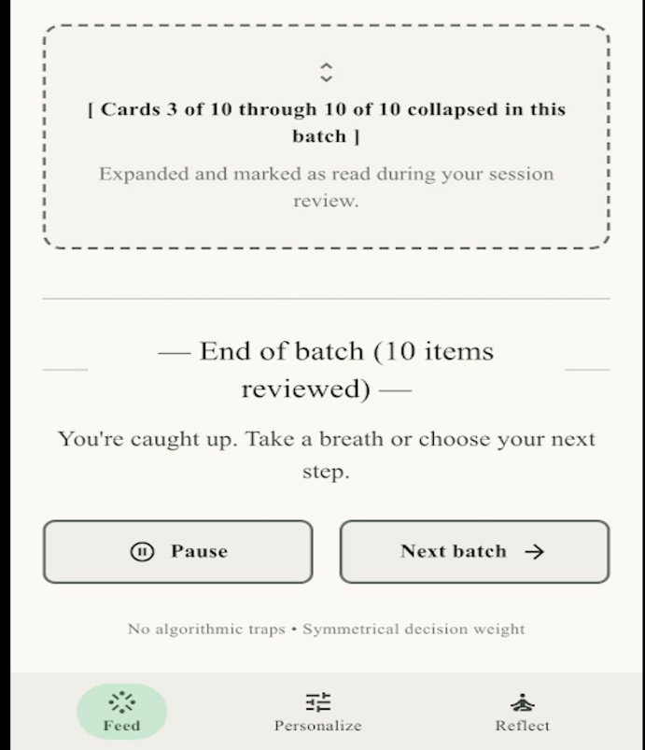
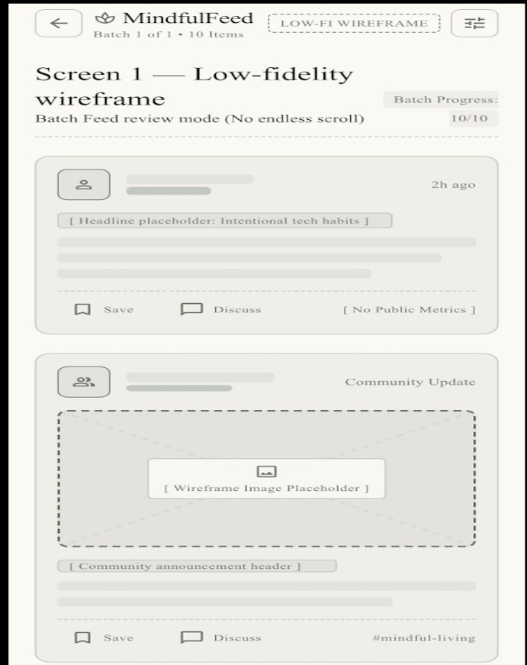

Figure 2: Low-fidelity wireframe: batch feed with explicit end-of-batch marker (Prototype v1)

Prototype v3: High-Fidelity Interactive System

In prototype v3 (Figure 4), the navigation flagged in v2 was flattened and additional features were added, such as a one-click "Continue without personalization" path, a preset-mode selector and an Ethical AI Compliance indicator. Because of the feedback from the v2, the preset modes (Focus, Discovery, Social) replaced the v2 tier selector. So, rather than engaging in thinking about the abstract idea of level of personalisation, v3 loosely asks the user to select a familiar intent and internally maps that selection to the same tracking granularity and content variability that was directly exposed in v2. It's at the cost of a loss of some technical transparency, however; part of the deal of the trade is that participants

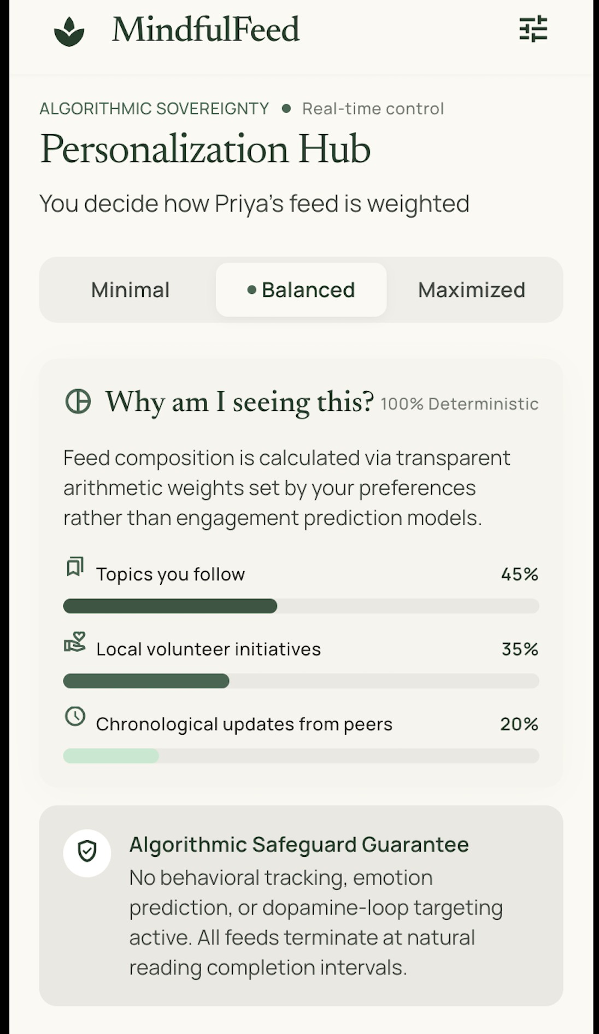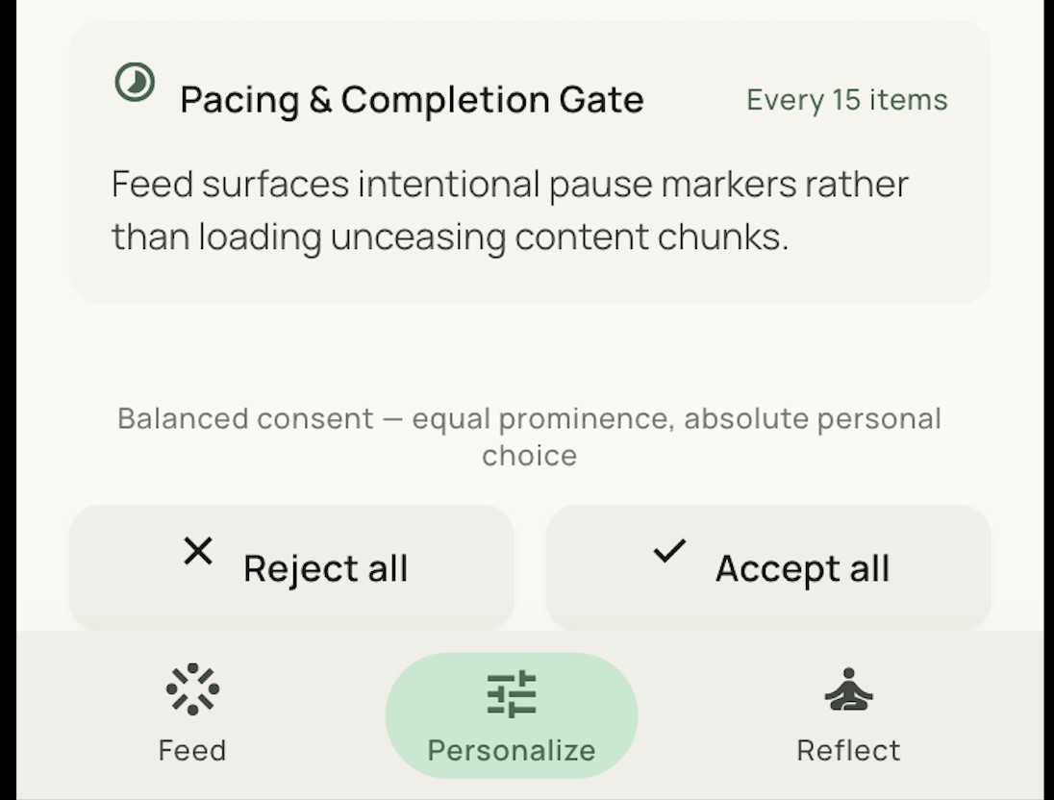

Figure 3: Mid-fidelity wireframe: algorithm control dashboard with symmetric consent (Prototype v2) The real cognitive load was reported when configuring v2, and in the trade no asymmetric defaults of the previous prototypes were reported.

Feedback and Redesign Summary

Table 7 traces the design decisions, feedback, identified dark-pattern risks, and redesign actions across the three prototype iterations.

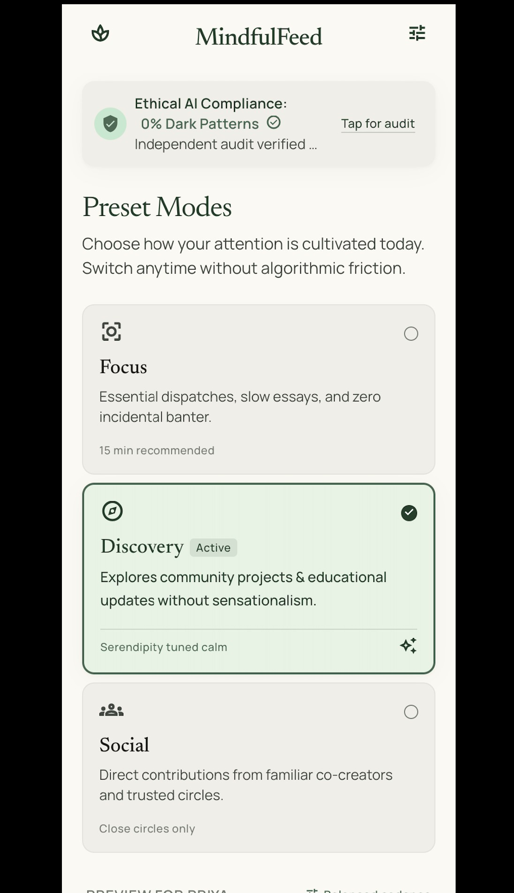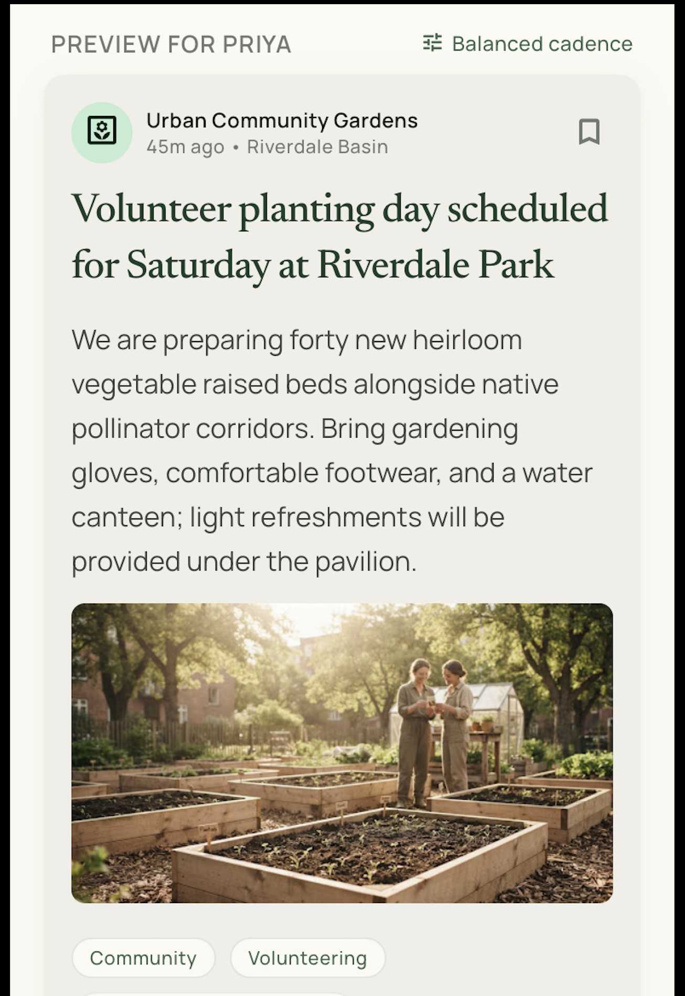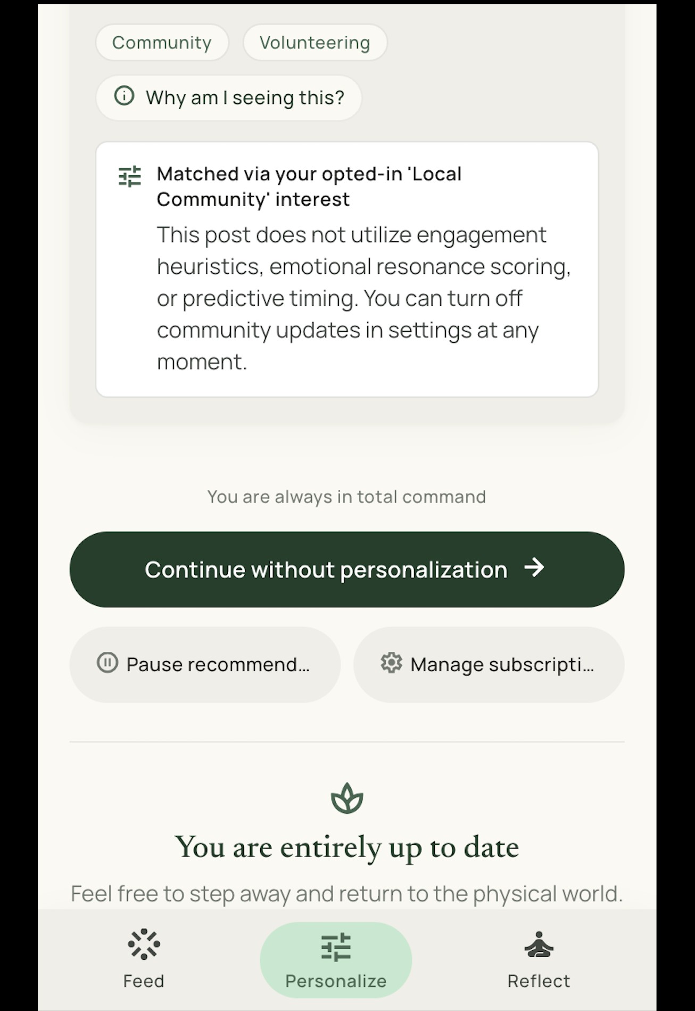
Figure 4: High-fidelity wireframe: preset modes, compliance indicator, and symmetric refusal path (Prototype v3).

Table 2: MindfulFeed interviewee profiles and burnout triggers

Name Role Goals with Mind-fulFeed
Burnout Triggers Representative Quote

Sakshi Undergraduate student

Arjun Marketing pro-fessional

Meera Community or-ganiser

Neil* Tech support specialist

Ashish* Software engi-neer
Stay socially up-dated between study sessions

Monitor trends and manage brand chan-nels efficiently

Coordinate events and advocacy con-tent

Quick entertainment and social check-ins between work tasks

Kill short gaps in the day; open, scroll briefly, close
Late-night person-alised recommenda-tions, fear of missing out, sleep-disrupting notification loops Overlapping work/personal feeds, pressure to respond instantly Repetitive sug-gested debates, emotional drain from conflict threads Reflexive hour-plus binges on football and meme content; harmful content sur-facing unprompted Low tolerance for irrelevant content; self-regulates by using mobile web instead of the app
"I open MindfulFeed for five minutes before bed and suddenly it is two hours later."

"My job is inside MindfulFeed, but sometimes it feels like I can never log off."

"I come here to support causes, but the arguments follow me every-where."

"Antisemitism." (his answer, un-prompted, when asked what frus-trates him most about his feed)

"Boring and simply not useful." (his answer when asked what frustrates him most about his feed)

Omkar* Engineer Occasional relax-
ation browsing, without deep invest-ment
Frustrated by over-personalisation nar-rowing content di-versity rather than by compulsive overuse; already deleted ev-ery app except one
"Too much personalisation which shows similar stuff." (his answer when asked what frustrates him most about his feed)

Rahul* Product man-ager

Imen* Not disclosed (self-described only as “im just a girl”)
Stay updated and connected with friends and col-leagues

Reduce compulsive doom-scrolling and ad exposure
Algorithmic drift from intentional friend up-dates into engaging-but-low-value video content; conscious of losing 15–20 min-utes at a time Repeated failed attempts at muting or limiting use; only deleting the app itself changed be-
"You end up watching the content that has no significance (but is just engaging) & a lot of such content." (his answer when asked what frus-trates him most about his feed)

"ads" (her answer when asked what frustrates her most about her feed)

haviour

Table 3: Empathy map synthesised from the three MindfulFeed interviews
Says Thinks Does Feels

“My feed makes me feel worse about myself after scrolling.” “Recommendations are repetitive and pushy, not really for me.”
“I keep checking notifica-tions even when I should be studying.”
“I do not fully trust plat-forms with my data or pricing.”
Worries that everyone else is doing better on-line.
Believes the algorithm pri-oritises profit over well-being.
Fears missing something important if offline.

Suspects data is tracked and pricing is opaque.
Scrolls for long periods at night despite intending to stop.
Dismisses personalised widgets faster over time.

Checks the phone during study or family time.

Clears cookies or switches devices to regain control.
Insecure about status and appearance.

Fatigued by being tracked and targeted.

Anxious, mentally drained, guilty about lost time.
Distrustful, feels a loss of autonomy.

Table 4: Define phase persona: Priya

Field Description
Age 24 years
Occupation Marketing coordinator with part-time community volunteering Tech usage pattern Checks feeds throughout the workday and again late at night;
several hours of daily use across professional and personal accounts

Goals for using Mind-fulFeed
Frustrations with current social media

Needs from an ethical feed
Stay informed and professionally connected while protecting sleep, focus, and emotional bandwidth
Notification overload spanning work and personal life, al-gorithmic opacity, comparison-induced anxiety, emotion-ally draining recommended debates, algorithmic drift into low-value engaging content (especially video), and over-personalisation that narrows content diversity even once un-derstood
Clear explanations for why content is shown, low-friction con-trols over personalisation intensity and diversity, content that does not amplify conflict or comparison, and a stopping point calibrated to her own habits rather than a single fixed thresh-old, since soft self-regulation tools have not reliably worked

for her before

Table 5: SCAMPER ideation for MindfulFeed feed features

Move MindfulFeed application
Substitute Replace infinite scroll with paged sessions and an explicit "Next batch" control to restore stopping cues.
Combine Combine diversity-enriched recommendations with fatigue-aware nudges that prompt a pause when over-engagement signals appear.
Adapt Adapt mindfulness-app break reminders into periodic reflection prompts before continuing to the next batch.
Modify Replace public engagement counters with a private, optional well-being check-in.

Put to another use
Use emotional-signal detection to surface calmer content instead of ampli-fying detected outrage or arousal.

Eliminate Eliminate autoplay for video and default push notifications tied to reactive engagement metrics.
Reverse Reverse ranking logic from most-engaging-first to most-balanced-first, pri-
oritising diversity over predicted click probability

Table 6: Desirability-Feasibility-Profitability matrix for MindfulFeed concepts

Concept | Desirability | Feasibility | Profitability
Finite batch feed with stopping cues | 4 | 4 | 3
Algorithm control dashboard (tiered | 4 | 3 | 4
personalisation)
Intentional friction / fatigue-aware | 3 | 4 | 2
pause nudges
Total ad prohibition | 3 | 3 | 3
Hard time locks | 2 | 4 | 2

Table 7: Feedback and redesign summary for MindfulFeed prototypes
Version Key decisions Feedback Dark pattern risk Redesign action

v1 Single inline con-sent banner; im-plicit personalisa-tion slider; default high personalisa-tion.

v2 Three-tier Per-sonalization Hub; modal consent with equal-weight Accept/Reject.
v3 One-click refusal path; preset
modes; Ethical AI Compliance indicator; pause toggle.
Users completed tasks but could not find opt-out; the cognitive walkthrough flagged a low-salience rejection option.
Improved per-ceived control;
some fatigue reaching granular toggles.
Higher perceived autonomy; resid-ual concern about long-term data re-tention clarity.
Interface in-
terference via
highlighted ac-cept; default bias from preselected high personalisa-tion.

Emerging ob-
struction from deep-nested ad-vanced options.

Reduced interfer-ence and obstruc-tion; residual mis-direction risk if fu-ture features com-pete for attention.
Elevate consent to a modal with symmetric ac-tions; add explicit tiers.

Flatten navi-gation; add a single-screen settings overview.

Lock symmetric flows as a design constraint; add retention-horizon indicators.

Strategic Evaluation and Reflection

Desirability, Feasibility, and Profitability

The evidence of ‘desirability’ was gleaned from the Test phase. Using v3, participants perceived greater autonomy and control in their interactions with v1, while walkthroughs with the final design revealed no unsolvable obstruction or interface-interference, consistent with previous research that a measurably greater sense of autonomy and control in symmetric opt-in/opt-out designs contributes to greater levels of trust (P et al., 2026, p. 2). But the solid proof was the trajectory itself: every recorded complaint there was a turnabout, an abrupt stopping point, a hierarchy of settings that confused – and every one was met by a single intervention, one intervention that could be traced.
This is no fringe omitting the real limits of the evidence. Three users in three brief test sessions is sufficient to provide needed information on detectible obstruction and one can determine a direction, but not to say the product would be desirable at any scale of use nor to say another fourth user and/or fifth might not find something Sakshi, Arjun, and Meera had not experienced. Also, the same 3 individuals viewed v1 and v2 and v3, an obvious confound as some of the improvement between v1 and v3 might be because people have become more familiar with MindfulFeed’s interface in general, rather than the specific redesigns tested here. To differentiate between learning effects and true design improvement you would need new participants at each step or at least a control group that only contacted v3, so the type of production evaluation would be needed. Both were beyond the scope of this project and are not addressed without the authors calling them limitations of the evidence.
It's five data points outside that confound; it's not two. A group of five actual participants (Neil, Ashish, Omkar, Rahul and Imen) walked all three prototype versions independently, and answered the same test questions (Section A) as a self-administered test. Not everyone's responses were steadfastly in support of the v1-to-v3 evolutionary trend described above; indeed the most obvious dissent from the trend was a collective pattern: Omkar, Rahul and Imen (the three v2 participants) identified v2, not v3, as the version they trusted most. Omkar's statement was clear: v2 “explicitly shows what's happening behind personalisation,” and for Omkar, the easier you make something to see, the more you make it accessible to him to control – the very antithesis to what v3's Autopreset modes were set up to simplify. We are more open about what is being shown to me” said Rahul, also giving v3 a positive overall rating. Imen selected v2 solely based on her ‘middle gut feeling’, and provided no explanation. Together, these three are not three isolated misreadings, but indicate that the preset-mode simplicity of v3, taken specifically in response to v2's feedback from using the test base on cognitive load (as described in Section 5), may have given up enough show to incur a loss of trust for some users without giving up enough benefit to earn their trust in the ease of use.
Despite this big picture, Neil and Ashish's first disagreement remains. Neil read v1's top-of-screen element as a marker of identification as opposed to a feed control, which he doubted v2 did, as he was not certain about the meaning of the “Bal-anced” tier label in v2, plus he thought he knew that there was no effort to detect AI-generated content, and that v1 was more trustworthy anyway “because it looks less like an AI slop.” Ashish didn't feel that he was being nudged by the consent screen and selected v3 specifi-

Calculating it was deemed to be “easiest to understand”, hence the book was written. Imen's walkthrough highlights a more pointed aspect of Neil's lack of understanding: he was unfamiliar with the term “batch” (what's a batch), didn't know what “0% Dark Patterns” meant (no idea)), and outright refused to accept any such premise: (Didn't even want to do it like an app, it's too bland... Both Omkar and Rahul stumbled upon the opt-out control of v2 through other means (the settings menu, or by using “Min-imal” tier, respectively) and not directly by hitting the reject action button on v2, which is the one that the v1-to-v2 redesign was supposed to have eliminated (Section 5). Five real, independent data, divided three ways over which prototype to consider most trustworthy and two ways over whether or not the interface vocabulary was even legible, does not reverse the conclusion drawn from three simulated test rounds. The evidence available to support this report was sufficiently extensive that solving interference with this evidence was easy to identify. It was too small to forecast that redesign's own greatest "usability victory," one that will come at the expense of some truth(s) on the side of real users.
Feedback from site users also reinforces a design decision from back in Define (Section 3.2) where we postulated that we were more inclined to avoid hard time locks on desirability – which the DFP matrix rated low in the first place – and to stick with autonomy preserving, soft control, symmetric consent and tiered personalisation. Imen's and Ashish's empathize-phase response, respectively, however, said that they had already tried soft self-regulation for themselves with no success and that the only way to achieve the desired use is to delete an app altogether. This failure mode wasn't explored in any of Mind-fulFeed's three prototypes, and the walk-throughs that the authors performed using their wireframes failed to prompt the participants to consider actually leaving the product rather than adjusting its settings. The report does not suggest a refutation of the finite-batch-feed approach — there is a possibility that an explicit, low-friction stopping point is a successful intervention where implicit self-discipline, muting, time limits, are unsuccessful, but the evidence gathered in this report is unable to differentiate.
A second restriction, is to whom or what was ‘desirability’ gauged? The walkthroughs and interviews asked the participants if they were able to find controls and whether they felt they were controlling the control of MindfulFeed's 'hard stop end' of the feed, but did not ask if their use of the app would sustain until a later date in the real world beyond the novelty. In v1, Sak-shi commented on the "cut off mid-thought" feeling she experienced on encountering the stopping point [time out] in the batch, a reminder by the authors that even a well-explained stopping point is still some friction, albeit one that perhaps in the course of a longer test period could be habituated or escalate into termination; this project didn't have the prototyping or test period yet to answer that question.
There were several challenges that limited feasibility, some of which involved a delicate balance between proving tiered person-alisation and not overstepping the boundaries of user control (as in the v2 version of Zulia); ultimately, the team decided to flatten the v2 tiered person-alisation in v3 of Zulia rather than remove user control. Another constraint was out of my reach for this project: the Recommendation engine. It is simple to show a "Why am I seeing this?" label in an interface for every feed item. Generating an accurate and understand-able explanation, to a non-technical user like me, is not; that's a decision on model architecture outside of the interface prototypes developed here, and is listed as a needs-to-be-done-sometime eligibility condition in the report.
Section 4.3 gives a score for DFP, and profitability turned out to be based on a subscription rather than on advertisement. Monetisation is most directly driven by ad and engagement, meaning it's ad-driven and aims to maximise engagement.
The product itself is aware of the dark patterns it wants to avoid (Mavi, 2025, p. 2), so designing the product as such would be counter-productive to the design criteria established in Define. It's also a subscription model which naturally accommodates Priya's stated concerns; what she wants to avoid is feeling ‘watched' and ‘used' for her time, and with a subscription model that's no longer the case, as the product optimises to renewals rather than viewer-engagement-point-maxing. There is no official test here as to whether people will actually pay for a calmer feed, and that's a real risk of money, not something that otherwise can be taken for granted.

Critical Reflection on the d.School Process

The five phase structure ensured there was a clear, auditable progression from the interview evidence (Empathize) to tested design (Prototype/Test), helping ideation to stay aligned with documented pain points, not presumed future features. One other useful effect of fixing the persona and POV statement prior to the Ideate phase was the disciplining effect it provides when ideas such as cross adaptive reward schedules emerged during the Ideate, the team could reject the ideas with a single qualifier: they didn't meet the persona's needs as stated in his POV statement. The biggest drawback is that it mainly appeared in Ideate. Approaches such as SCAMPER and the DFP matrix work great for concepts at the interface level but do not tell much about how the underlying recommendation algorithm should be trained or audited. This gap was only filled at the level of design constraints: symmetric effort, explainability, human oversight. It did not involve algorithm design itself and it would be disingenuous to suggest that it did.
The second limitation is more procedural in nature and only became apparent in retrospect. The five phase model incorporates Prototype and Test as a single phase. Instead, this project was a series of short cycles—build, test, redesign, build, test, redesign, build, test, redesign—that is, it was not one extended prototyping phase followed by a single test. The positive there is that it was real, and that in three smaller rounds of feedback we could make more and smaller redesign decisions than in one large round of feedback. That expense was revealed later, in the Evaluation section above: it was more difficult and less neat to determine how much of a certain improvement was attributable to the change in the operating mode to PRESET, how much to the easier-to-learn flat navigation, or how much to this combination. A better experimental design would have manipulated only one variable at a time between the prototypes. In both v1-v2 and v2-v3 cuts, a number of changes were implemented simultaneously – transitions which lack causal clarity but opt for quick development, transitions which – with more time – the team will execute differently.

Conclusion

Synthesis of Results

This project report documented MindfulFeed's design thinking process – from selection of three empathize-phase in-terviews to the creation of a synthesized persona and a POV statement, to the four How Might We?" questions and the various concepts that emerged through the SCAMPER process and were vetted in a DFP matrix to three successive proto-types tested. One specific artefact was created for each phase rather than a general discussion of the problem space. All design changes in the Prototype/Test cycle are based on documented usability feedback – not assumptions: the implicit slider (v1) was made explicit tiers (v2) and then to preset modes (v3), as a result of the specific usability findings made in the table shown as overall findings – there has been no unstructured iteration in any of this development.
The emerging product record reveals a viable journey from documented harms to users, through compulsive engagement, to algorithmic opacity then to fatigue from conflicts to an interface of permissions: batch feeds, tiered personalisation, symmetric consent and non-manipulative monetisation. The small point is also the evidence-based persona in Section 3.2; it can be used to capture design-relevant detail from more interview-candidatures than it literally represents, as long as this step of the synthesis is written down, instead of left implicit.

Critical Reflection on Methodology

Where duh' was already set out in Section 6.2.Auditable trace from an inter-view evidence to a tested design, then: School model earned its keep and the DFP matrix has almost nothing to say with regard to the actual training and auditing of any underlying recommendation algorithm. That limitation is extended to what has yet to be done. Addressing algorithmic-governance gap was merely as a design constraint, symmetric effort, explainability, human oversight, no algorithm specification; this is too much for a 5-phase DT process as a standin for governing the algorithm itself.

Outlook for Future Practice

As mentioned in Section 1.1, a designer opting for a dark pattern 10 years ago would well have ended up in a terrible blog post, but today it would be a matter for a regulatory decision under the Digital Services Act, and the promised EU Digital Fairness Act (Q4 2026) will directly limit manipulative interfaces. More precisely, the core controls of MindfulFeed, featuring symmetric opt-in/opt-out consent, explainable personalisation tiers and a one-click refusal path were all designed to align with the desirability and feasibility scores of the DFP matrix, not specifically for a particular regulation phrase. It's no secret that the practical implications that this project is aimed towards should push ethical interface and interaction design, including that catchy ‘ethicization’ Sue was talking about, from a differentiator, a way to stand out, toward a compliance baseline that platforms active in the EU will have to adhere to, whether or not they are advertising it. Whether MindfulFeed's particular mechanisms—batch feeds, tiered consent, etc.—will pass muster in a future DFA inspection is not a question that this report can speak to; what this report can speak to, however, is that this mechanism-building, based on documented use, rather than based on the language of an anticipated regulation, is a defensible first step in that transition.

References

Dadage, M. (2026). Impact of social media on student mental health: A legal and ethical analysis. Journal of Advances and Scholarly Researches in Allied Education, 23(3). https://doi.org/10. 29070/m0c7h331
Gray, C. M., Santos, C., Bielova, N., Toth, M., & Clifford, D. (2021). Dark patterns and the legal requirements of consent banners: An interaction criticism perspective. Proceedings of the 2021 CHI Conference on Human Factors in Computing Systems. https://doi.org/10.1145/ 3411764.3445779
Mavi, P. (2025). Dark patterns: Understanding consumer awareness &amp; regulatory mechanism. Don Bosco Institute of Technology Delhi Journal of Research, 2(2). https://doi.org/10.48165/ dbitdjr.2025.2.02.04
Özkürkçü, E., & Dog˘ anay, D. (2025). Mindfulness and the unseen: Understanding the impact of dark patterns in mindfulness applications. Proceedings of the Design Society, 5. https://doi.org/10. 1017/pds.2025.10257
P, A., M, K. K., Puneeth, M. V., G, N. G., S, D. H., & R, D. G. (2026). Detection and analysis of dark patterns in modern web applications. International Research Journal on Advanced Engineer-ing and Management (IRJAEM), 4(05). https://doi.org/10.47392/irjaem.2026.0301
Padmaavathy, P. A., Dinesh, S., Karthika, M., & Sree Raksha, G. (2026). The digital dopamine loop: Behavioural psychology, artificial intelligence and sustainable digital well-being. STAN-ZALEAF INTERNATIONAL JOURNAL OF MULTIDISCIPLINARY STUDIES (SLIJMS), 2(3).
https://slijms.com
Papari, A. C., Ghervase, D.-G., Ilincu¸ta, A.-M., Geamalinga, N.-R., & S, unda, I. (2026). Neurolaw and social media governance: Neurorights, platform design, and the eu regulatory response: A comprehensive scientific literature review. Veredas do Direito, 23(9). https://doi.org/10. 18623/rvd.v23.6859
Ronald, D. (2025). Digital well-being in the age of artificial intelligence: A review of emerging research. Stout in Computer Science and Technology Studies, 1(1). https://doi.org/10.61424/q229t137 Ukgoda, H. (2024). The dark side of social media: Analysing dark pattern combinations and their impacts. IJIE (Indonesian Journal of Informatics Education), 8(2). https://doi.org/10.20961/
ijie.v8i2.91666

Appendix: GenAI Usage Disclosure

Generative AI tools were used in this project in three specific, bounded ways, disclosed here in line with the university’s plagiarism and AI-use guidelines.

- Simulating interview quotes and empathy-map synthesis (Section 2.2 and Section 2.3). The three interview profiles (Sakshi, Arjun and Meera) and the respective quoted responses were created with the help of AI over three different usage scenarios (student, working professional and community organiser) due to limitations in recruiting and interviewing real users for this exercise. Sentence prompt employed: "Re-enact a semi-structured interview excerpt taken from a [role] regarding the experienced level of frustration over [specific dark pattern] in their own words, one quote, and emotional impact reported. Rationale: The brief for the assignment clearly gave permission for the use of qualitative data from users as simulated; this was therefore openly identified and then applied design judgement by the project team when selecting which simulated themes to retain and how they will code these into the empathy map. To meet the additional condition that real users must be used in combination with AI-generated data, five additional real users were separately recruited (Neil, Ashish, Omkar, Rahul and Imen, Section 2.2) and interviewed with the same interview questions, and a complete walkthrough of each of the three prototype versions (Section 5), with a self-administered testing tool specially built for the purpose - a single-file, offline web page containing no external links or databases, and none of the data being transmitted anywhere. Their answers are typed straight from them, and recorded with an automatically logged answer time for each question, and reported without any editing whatsoever including, where they contradict the simulated evidence or each other. The wording of questions for the tool, except for those used in the wireframe-walkthrough, was drafted with AI assistance, while the set of empathize-interview questions was independently drafted from the same structure described in 2.2, but none of the five real participants responses were drafted with AI assistance.
- Language editing. Phrasing improvements and checking of gram-mar/style consistency of drafted sections were recommended using AI tools. All factual and citation material was written, sourced, and verified by the writer from original literature; AI was not used to create citations, sources, or content for the SCAMPER, DFP table, or feedback/re-design table or summary of which resulted from the writer's design judgment.
- Prototype mockup generation (Section 5, Figures 2–4). Three prototype visuals were created using an AI UI-generation tool (Google Stitch) based on a prompt from the contents and elements of interaction that the project team had pre-designed in Spanish based on the DFP selected concepts and the progression of v1/v2/v3 feedback (such as the batch-feed structure, the three-level Personalization Hub, the preset-mode selector and compliance indicator). While the tool generated the visual layout, the underlying decisions around the design, naming of controls, information architecture and re-engineering of the design between versions were made by the team conducting the project and were based on the outcomes of the cognitive-walkthroughs reported in Section 5.

No AI tool was used to generate the reference list or any numerical scoring in the DFP matrix.

Appendix: Real-User Testing Tool

To gather the five real participant responses mentioned in Section 2.2 and Section 5, the project team created a small, auto-administered testing tool, instead of opting for manually-facilitated sessions. Its approach, the quality of the questions presented and its target and hosting have been documented here as evidence of its approach not just claims to do so as it must use real people in combination with AI-generated information (Section A).

Strategy

The tool had one combined session per participant, giving both prototype type questions and empathise type habit questions (Total of 8 questions), which took about 10-15 minutes will all questions given together. The framing the participants got was very limited before they started, namely that they would have to respond to three versions of an app screen, after which they were to answer general habit questions, without getting a description of the design rationale behind the app screens, the DFP scoring, or the team's expected answers. This followed the same rationale as the wireframe questions themselves were based on, which came from the unprompted impressions, or first impression, items in the human artikulated assessment testing protocol (Section A, item 1).

Questionnaire Quality

The sixteen questions were presented sequentially with the corresponding wireframe image (when they required it); and the actual time each question appeared and an answer was provided was captured by the tool. That per-question response-time log proved crucial: Rahul's response time for the first wireframe question, 750 seconds, and Imen's, 14 seconds, were evidence of the different ways that two real people interacted with the same wireframe prompt—and data a plain transcript couldn't show. To prevent a full demographic form, participants provided a single line self-description (e.g., 29, swe, has no time) and thus provided the profile information necessary for Table 2 without having to complete a lengthy demographic questionnaire. The answers provided here were free-text (i.e., unrecognized) and directly captured from the computer via the keyboard and the word used in Section 2.2 and Section 5 is that as actually entered by the participant – unless a paraphrase or summary is explicitly indicated.

Target

The tool aimed at persons who have not previously experienced MindfulFeed's design thinking and not been involved in the project at all. Five were then recruited (Neil, Ashish, Omkar, Rahul, Imen) deliberately outside the project team, in order to not have the interface-familiarity confound that was identified for the three-simulated-participant test rounds (Section 5).

Hosting

No server-side component, data consists of single HTML / JavaScript page, data stored client side, manually downloaded and sent back by the participant at the end of the session. The landing screen of the tool clearly says "Nothing is sent anywhere automatically. It was hosted with Wasmer (in order to drop it to every participant as a single link, and not as a file attachment) as this allowed to dissolve distributing the tool itself. This does not affect the way that Response data traveled: Response data never left the participant's browser unless the participant opted to upload the downloaded file separately.
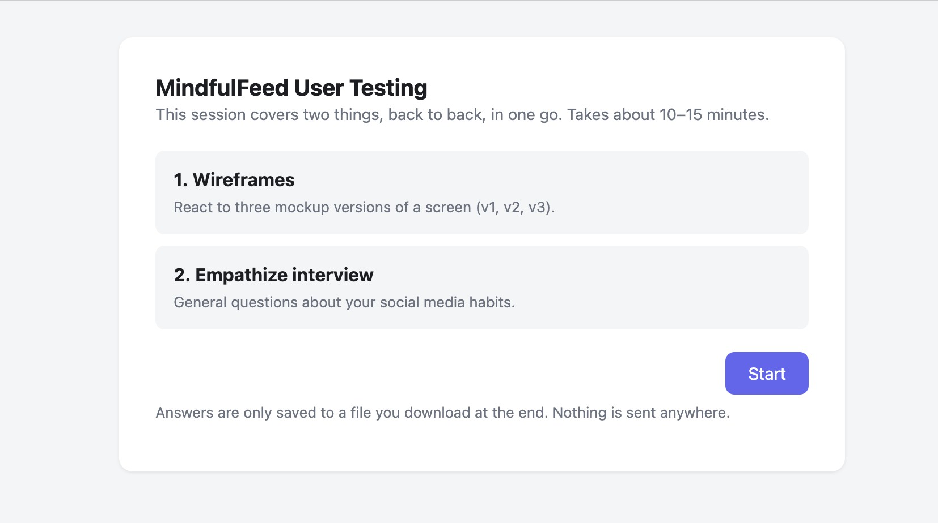
Figure 5: Real-user testing tool: screen 1
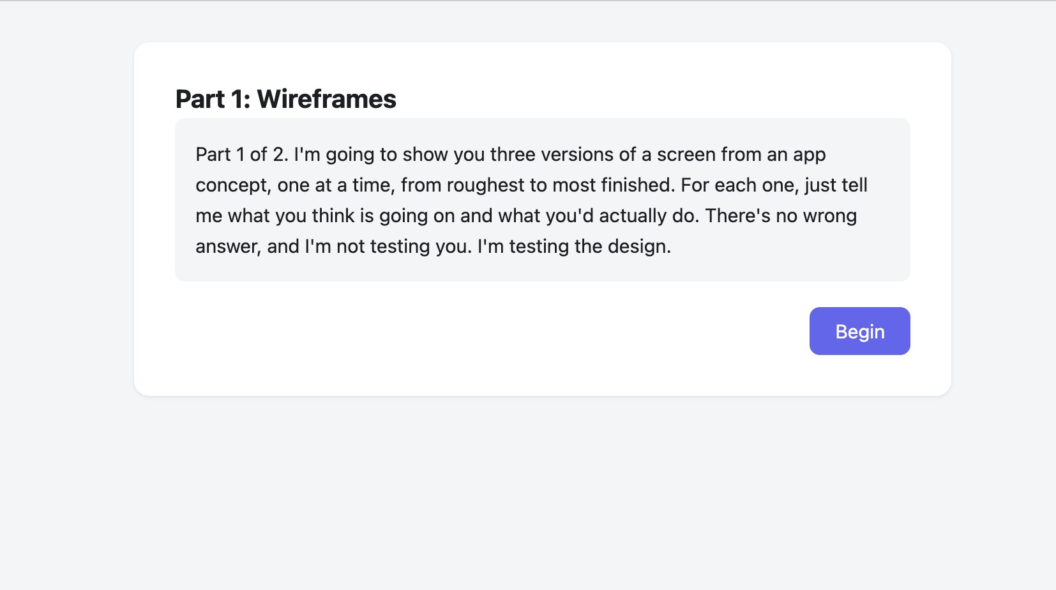
Figure 6: Real-user testing tool: screen 2

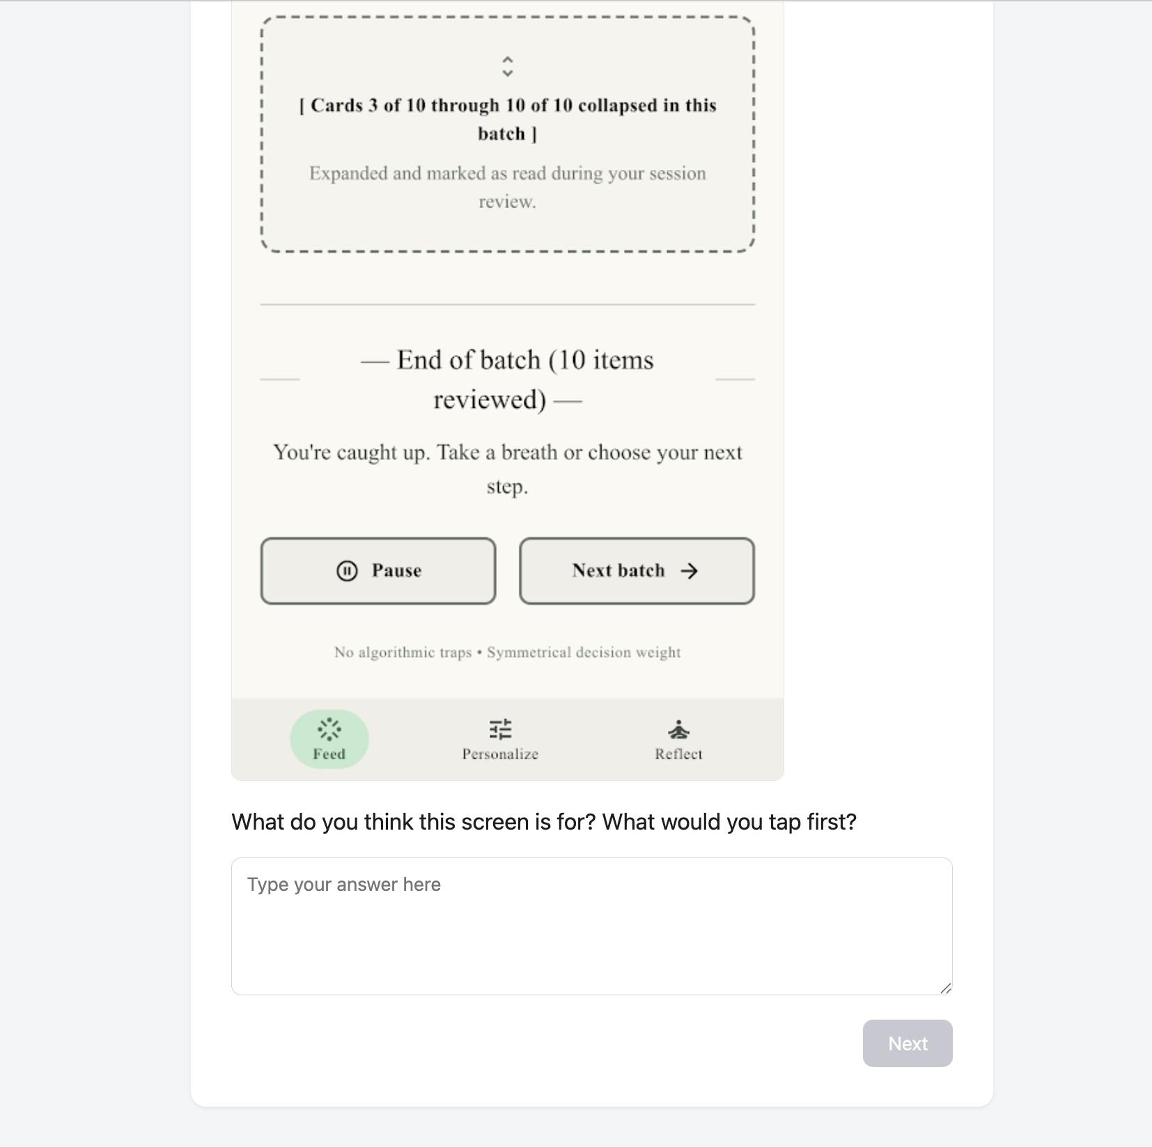
Figure 7: Real-user testing tool: screen 3

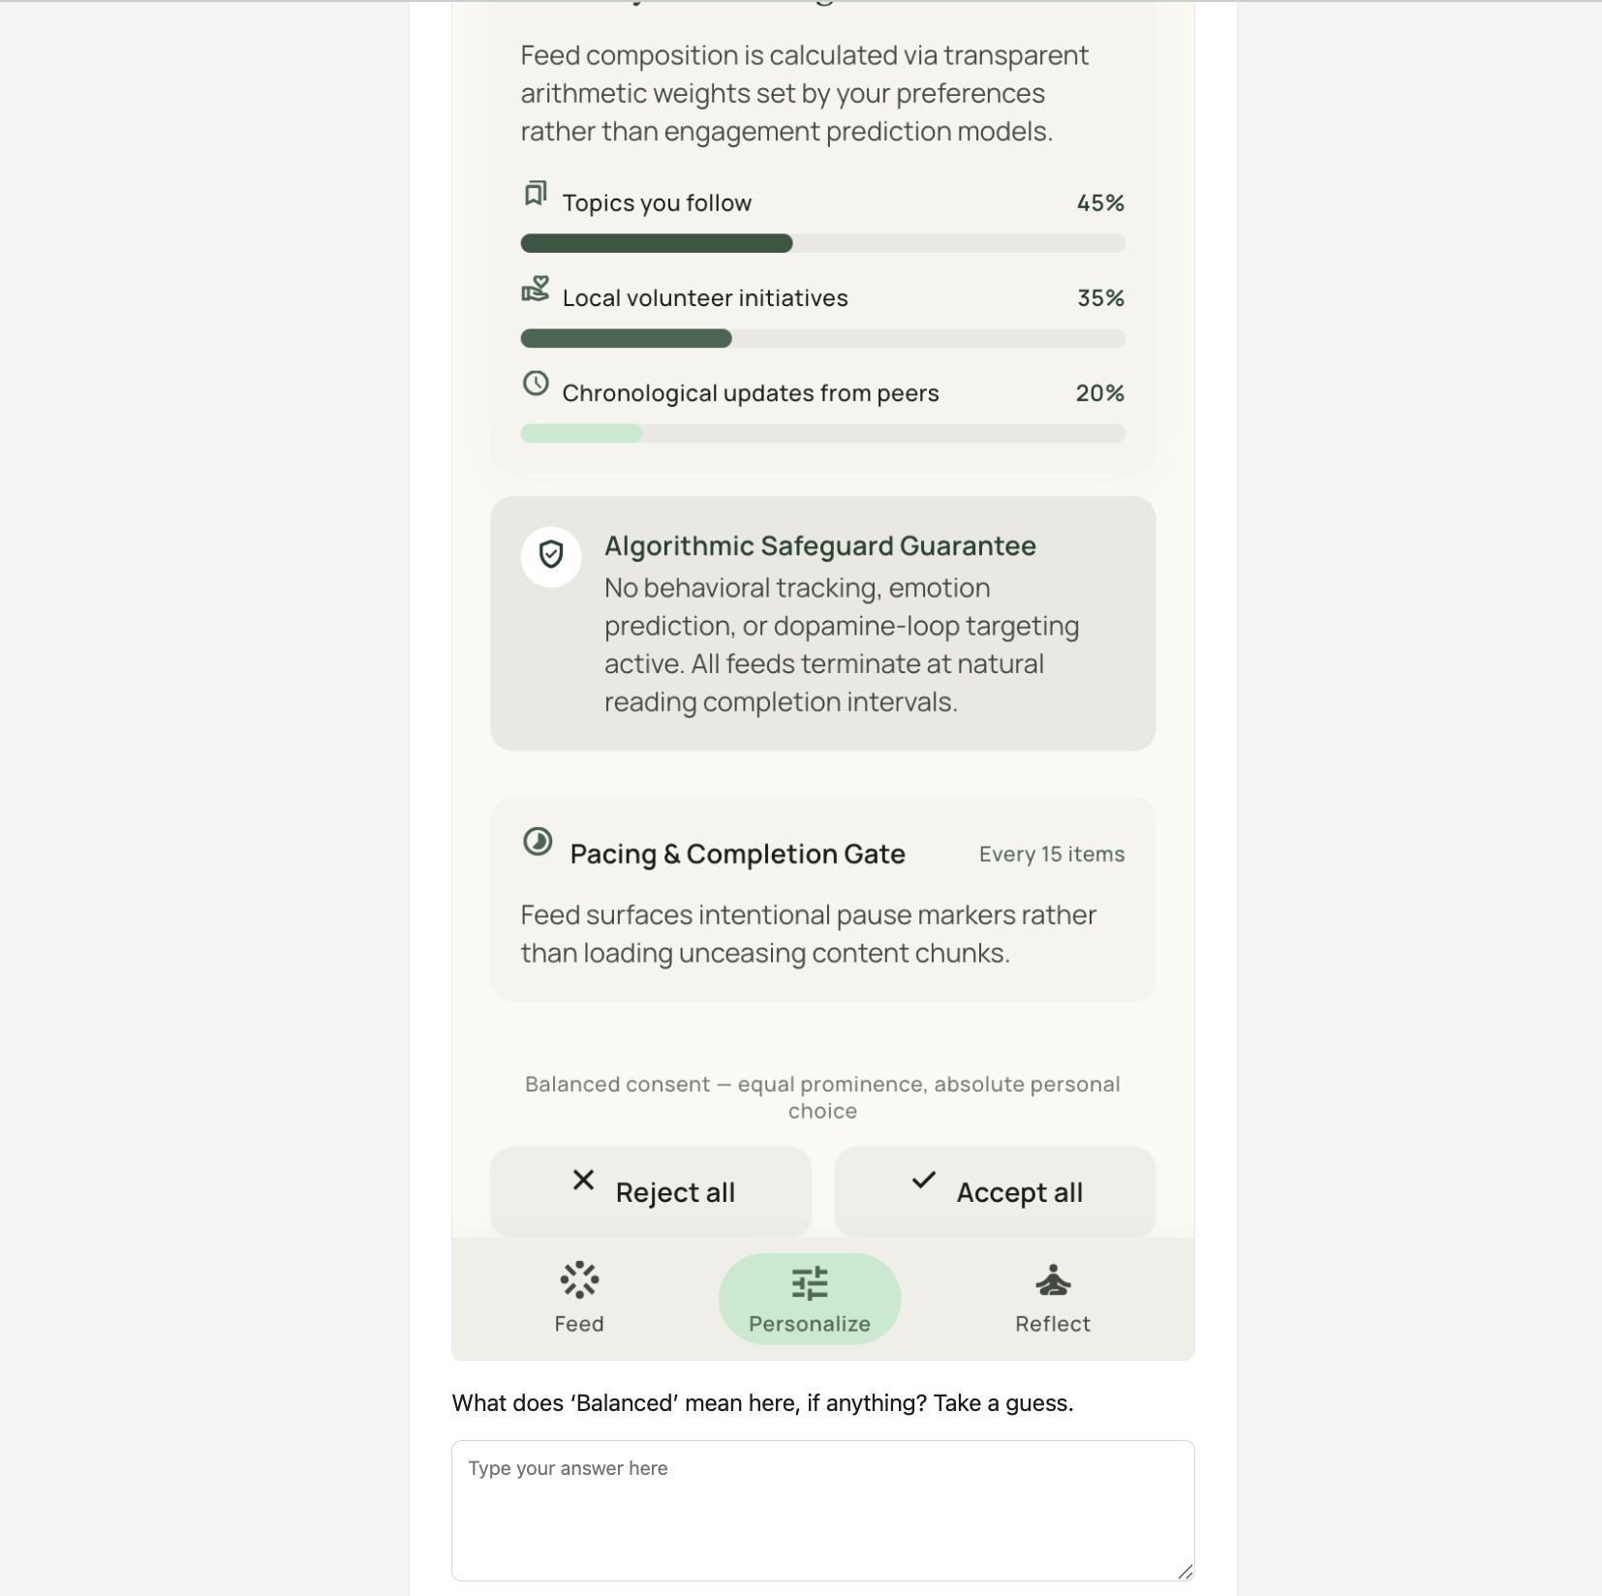
Figure 8: Real-user testing tool: screen 4

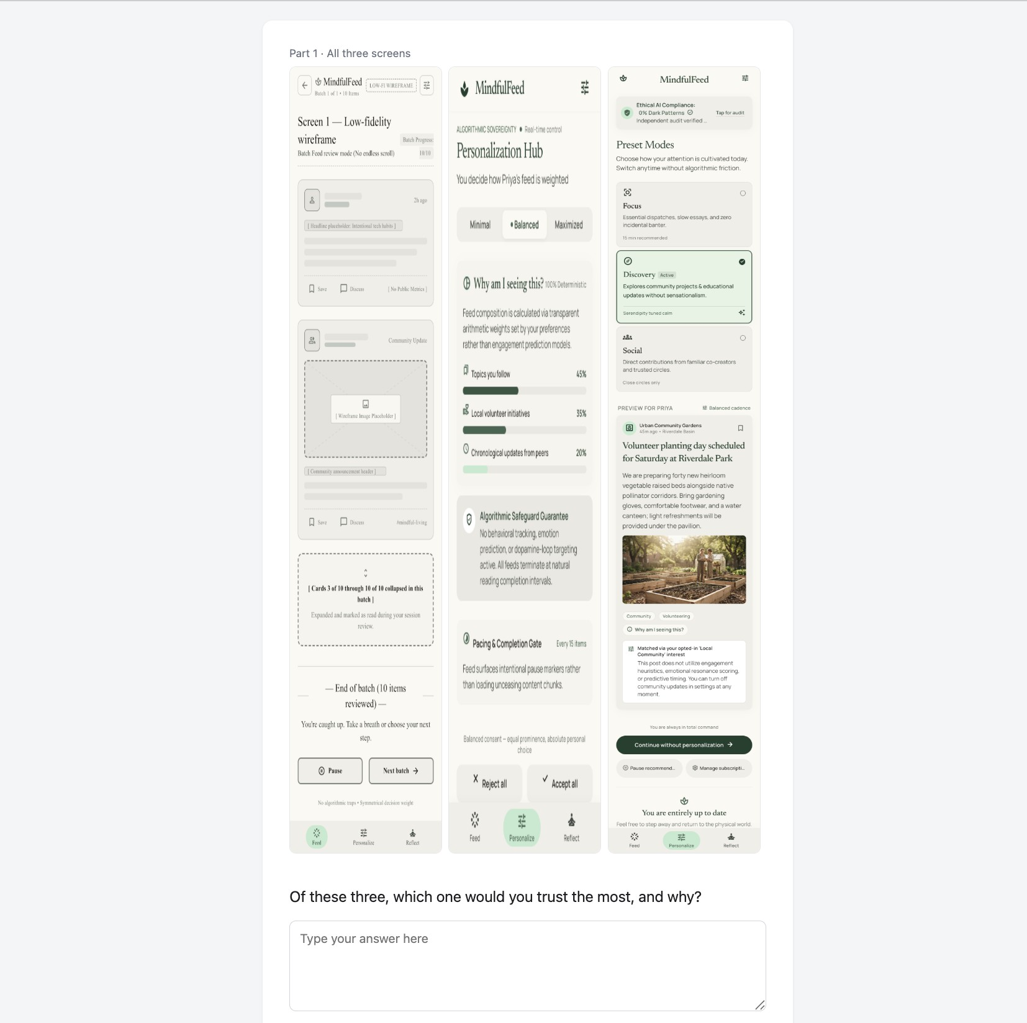
Figure 9: Real-user testing tool: screen 5

Figure 10: Real-user testing tool: screen 6
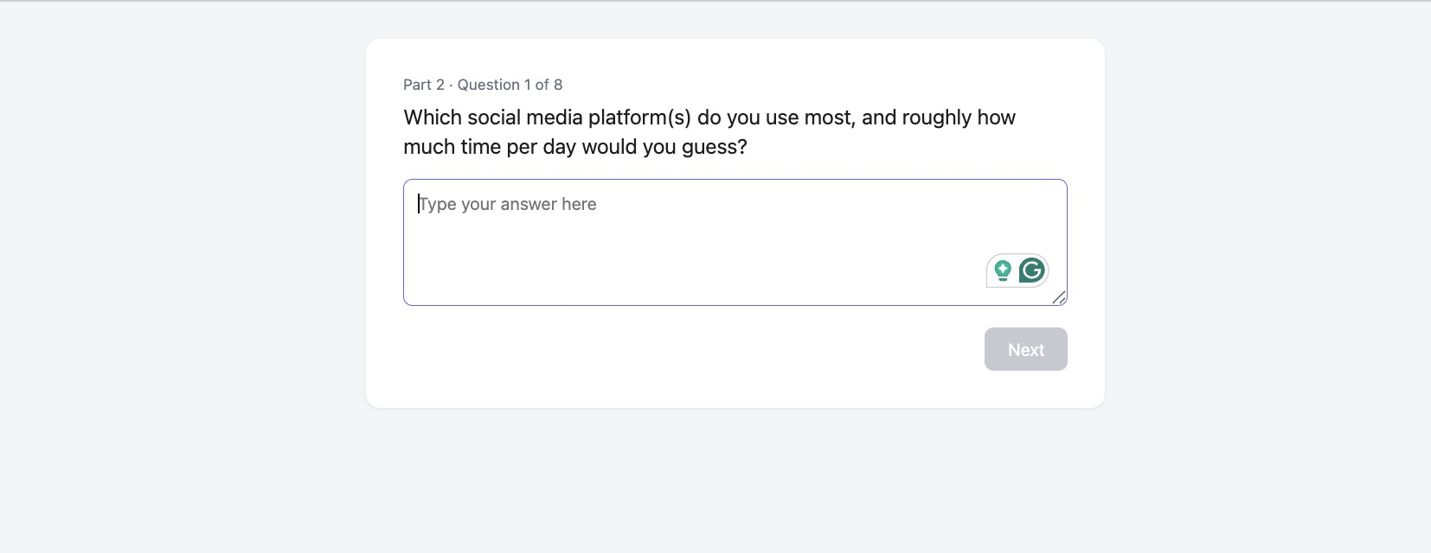
Figure 11: Real-user testing tool: screen 7

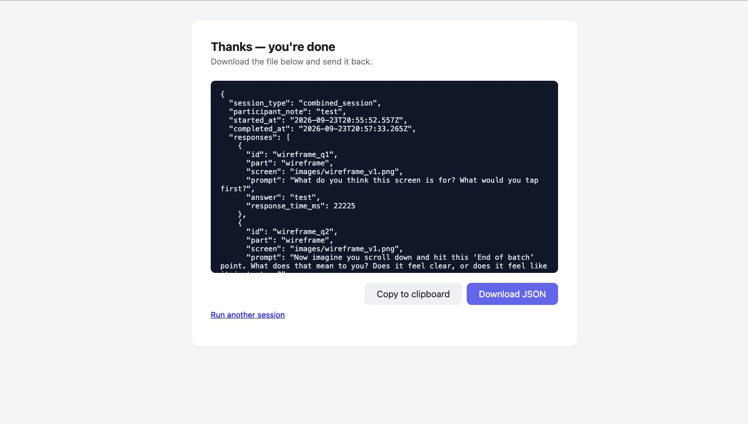
Figure 12: Real-user testing tool: screen 8

